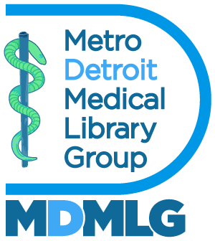

Executive Board Meeting June 20, 2024

**Annual Report 2023 - 2024**

Outreach – Social Media Manager

**Goals and Objectives**

1. To showcase events, professional development opportunities, celebrations etc. happening within the MDMLG community.
2. To bring awareness of medical librarianship particularly to student members.
3. To speak to the benefits of joining MDMLG.

**Accomplishments**

Over the past year,­­ I was given the opportunity to speak to WSU MLIS students about medical librarianship and the benefits of service. We also clearly defined the role of the student representative and posted it on the website for transparency.

**Metrics**

Our Instagram account: @*DetroitMedicalLibraryGroup* has 50 followers and 216 posts. Our facebook group has 18 followers and 65+ posts.

Respectfully submitted,

Michelle Rau

Social Media Manager